metin, küçük resim içeren bir resim

Açıklama otomatik olarak oluşturuldu

**ABDULLAH GUL UNIVERSITY**

**Software Engineering Project Report**

**C-Trend**

**Submitted by**

Rumeysa Betül KAYRAK

Mustafa YILMAZ

Yakup LAÇIN

Yusuf BİLGİN

**JUNE 2020**

**Content**

I Project Description 2

1 Project Overview 2

2 The Purpose of the Project 2

2a The User Business or Background of the Project Effort 2

2b Goals of the Project 3

2c Measurement 4

3 The Scope of the Work 4

3a The Current Situation 4

3b The Context of the Work 4

4 Product Scenarios 5

4a Product Scenario List 5

4b Individual Product Scenarios 5

5 Stakeholders 6

5a The Client 6

5b The Customer 6

5c Hands-On Users of the Product 7

5d Priorities Assigned to Users 7

6 Mandated Constraints 8

6a Solution Constraints 8

6b Implementation Environment of the Current System 8

6c Partner or Collaborative Applications 8

6d Off-the-Shelf Software 9

6e Budget Constraints 9

7 Naming Conventions and Definitions 10

8 Relevant Facts and Assumptions 10

8a Facts 10

II Project Issues 11

9 Open Issues 11

10 Off-the-Shelf Solutions 11

10a Reusable Components 11

11 New Problems 11

11a Effects on the Current Environment 11

11b Effects on the Installed Systems 12

11c Potential User Problems 12

11d Limitations in the Anticipated Implementation Environment That May Inhibit the New Product 12

12 Tasks 12

12a Project Planning 12

12b Planning of the Development Phases 13

13 Migration to the New Product 14

13a Data That Has to Be Modified or Translated for the New System 14

14 Risks 14

15 Costs 15

16 Waiting Room 15

17 Ideas for Solutions 15

18 Project Retrospective 16

III Design 16

19 System Design 16

19a Design goals 16

19b Current Architecture 17

19c Proposed Software Architecture 19

19d Subsystem Services 20

19e User Interface 21

20 Object Design 26

21 Test Plans 26

IV Project Issues 28

22 Product Use Cases 28

23 Performance Requirements 29

23a Speed and Latency Requirements 29

23b Precision or Accuracy Requirements 29

23c Capacity Requirements 30

24 Dependability Requirements 30

24a Availability Requirements 30

24b Robustness of Fault-Tolerance Requirements 30

25 Maintainability and Supportability Requirements 31

25a Supportability Requirements Content 31

25b Adaptability Requirements 31

25c Scalability or Extensibility Requirements 31

25d Longevity Requirements 32

26 Security Requirements 32

26a Access Requirements 32

26b Integrity Requirements 32

26c Privacy Requirements 32

27 Usability and Humanity Requirements 32

27a Ease of Use Requirements 32

27b Personalization and Internationalization Requirements 33

27c Understandability and Politeness Requirements 33

28 Look and Feel Requirements 33

29 Operational and Environmental Requirements 33

29a Expected Physical Environment 33

29b Productization Requirements 33

30 Cultural and Political Requirements 33

30a Political Requirements 33

31 Legal Requirements 33

31a Compliance Requirements 33

# Project Description

## Project Overview

Twitter is one of the leading micro blogging social media platforms. The latest topics shared by users change from day to day, depending on their location. To keep up to date with current topics on Twitter, we need a wrapper app that collects real-time trends and displays them to the user. This application should be able to present the emerging trends to the user both for the preselected regions and for the global.

## The Purpose of the Project

### The User Business or Background of the Project Effort

Content

At a glance, you can reach what is happening on social media in those moments via Twitter. Twitter trends are very helpful as they help us understand what people think about and how they stand on trending topics. What makes this so useful is that you can see in real time exactly what individuals are saying as opposed to just talking about something. Being able to predict trending topics makes it an excellent resource for organizing your calendar. After a while you may find that certain trends become predictable. For example, recurring hashtags like #mondaySyndrome or #mondaymotivation will continue to trend every week. In this case, you can include these hashtags in your program or content plan. It's also an opportunity to plan your content ahead of time by anticipating that other predictable events, such as holidays and seasonal events, will be talking about those events on Twitter that day as well. In addition to these, it also allows you to be in control of what is happening on the other side of the world. At this point, you may be interested in trends other than just your location. Or having constant trips or connections abroad pushes you to follow trends. You may just want to follow the trends. This project serves exactly that. Motivation

The most mentioned word on Twitter is trends. Many topics are on the Twitter trends list. These can include natural events, market changes, political scandals and other breaking news. Trends has a very strong ability to promote public events. Also, a twitter user posts a different tweet every day. At this point, the data is kept in the database. It's almost a dream to hold large volumes of data, analyze it, and find trends that show what's been going on lately. At the same time, each tweet points to a specific purpose and a problem or discussion.

Considerations

You need to change the location settings to stay out of the trends that come to the location you set on Twitter. Achieving trend tracking of different locations is time consuming.

### Goals of the Project

Content

The main purpose of the project is to add the countries you want to your list, and you can reach their trends, and you can even select the trends of not only countries but also some cities or states on this trend page. Apart from this list of selected regions, there is also the notification of the trends of the selected region from the notification settings at certain intervals without entering the application.

Motivation

You won't have to spend time constantly logging into the app and seeing what's going on. You should follow a great notification setting so that you can have a very quick and comfortable glance. All you have to do is select the country, city or state you want and then select the time range you want. In this way, you can take a look at instant trends while looking at what time it is with notifications that come at regular intervals. At the same time, you can go to the application from the notifications and reach not one but several regions that you have determined in your selected country list.

Examples

We want it to be able to select as many countries as it wants to the selected region list.

We want to be able to turn off the bird sound that will come at the entrance on the login screen of the application.

We want users to be able to choose the region they want to receive notifications from in the notification settings.

### Measurement

They will not need to enter twitter as they reach the trends in the content of the notifications that come only at the desired time intervals of the determined region without entering the application. They will be able to follow trends only with notifications. In addition, by entering our application, the trends of other selected regions are easily accessible without changing their location.

## The Scope of the Work

### The Current Situation

Content

This project appeals to people of all ages and from all parts of the world. The usage environment of this project has a very wide scale. It provides intercontinental communication. It causes intercultural interaction.

Motivation

Motivation is a force that initiates the behavior of work-related individuals and determines its direction, form, duration and intensity. This project is also triggered by motivational notifications.

### The Context of the Work

Content

Within the scope of this study, there is the Twitter application on which we base our application. At this point, the people involved in the project should be Twitter users and should know which algorithm Twitter follows, whom it is addressed to, and what its purpose is. Also, it is Twitter trends that the app focuses on. The pros and cons of the trending part of Twitter should be examined.

Motivation

To grab the attention of users, we have to offer something new that Twitter doesn't have. So, the top 20 trends, which are the focus of the project, should be examined. In this case, more focus should be placed on the issues that Twitter is missing.

## Product Scenarios

Scenarios are somewhat informal stories describing how the end users would use the product once it is completed. They take the form of narratives and may involve specific individuals and examples.

### Product Scenario List

tablo içeren bir resim

Açıklama otomatik olarak oluşturuldu

### Individual Product Scenarios

First, you need to register at first and if you are registered you can login. When you realize that you forgot your password on the page you will log in, you should click on the forgot password button and then enter an e-mail address that belongs to you. You can easily set a new password via the link in the e-mail you entered. Then the page that welcomes you is the selected countries page. This page is blank if you have never made a selection before. If you have made a choice, the existing countries are still on the screen in the same way. If you want to add, you will go to the countries page with the add the region button. You can easily find the country you want manually or using the search button. When you press the edit icon on the selected regions page, you can remove the selected countries from your list. You can also switch to the settings page from this page with the settings button. Before talking about it, the selected regions are on your screen with their flags and names, if you click on the flag, you will go to the trends page. Top 20 trending list welcomes you. At the same time, you can reach the cities or states of the selected country with the pop-up button. If we come to the settings page, on this page you can update your password, change the theme of the application and make notification settings. You can select a country or city in the notification settings and set a time range. Thus, when you are not in the application, the first two trends of the country or city you selected will meet you at the time intervals you set in the notifications.

## Stakeholders

### The Client

Content

We are designing a mobile application in our project. You can access this application, whose name is C-Trend, through Google Play and App Store.

Motivation

C-Trend has a selected list from both **C**ities and **C**ountries. You can reach the trends of the regions in this list.

Considerations

Like Twitter, C-Trend is taking its place in Google Play and App Store.

### The Customer

Content

The person who wants to buy our product may be aware of the place of social media use in our lives and may be interested in trend tracking.

Motivation

Social media usage is increasing day by day, and they are platforms that add new users every day without slowing down.

### Hands-On Users of the Product

Content

● Username/category: Appealing to people of all ages

● User role: Following trends

● Subject experience: Driving social media usage according to trends

● Technological experience: Technological experience is not very valuable

● Other user features: It is suitable for use regardless of gender, age, education. The language of the application is English. Users need to know English.

Motivation

It is open to anyone who knows the English language.

### Priorities Assigned to Users

Content

● Key users: Key users are people who are responsible for closely following the agenda of many people, such as active, famous, phenomenon, journalists or brand owners on all social media platforms.

● Secondary users: They are groups of people who use Twitter and follow trends.

● Unimportant users: They are people who have just registered and checked out our application. It is a group of people who are far from following the trend.

Motivation

It is an advertising and business opportunity that is an open market for phenomena and brand owners. In a way, it is an indispensable part of your business. The fact that they are not indifferent to what is happening in the world and that they have an opinion on the trends keeps their names alive.

## Mandated Constraints

### Solution Constraints

Content

Description: The product can only be used by logging into the application. However, it has a notification system that will continue to work as long as it is not logged out.

Rationale: The product will attract the most attention by the phenomenon and brand owners. It will follow the trends moment by moment.

Fit criterion: The product must be running in the background.

### Implementation Environment of the Current System

Content

The technological environment in which the product will be installed is telephones. Since we integrate the notification system with the discord bot, discord should always be running in the background.

Motivation

Being a mobile application is the phones that we carry with us all the time, even for a moment.

### Partner or Collaborative Applications

Content

Of course, our Twitter collaborator. Because thanks to the API it offers, we can reach the trends. At the same time, it can be said that we are a full collaborator on discord. Our Discord bot notification provider.

Motivation

At first, it was quite difficult to reach API keys. If the API does not provide the application will not work. If discord crashes, this point in our notification system crashes too.

### Off-the-Shelf Software

Content

The open-source Twitter and Flutter's ready library on Trends are the basic requirements that make this application possible. Provides off-the-shelf software (OTS) to our Twitter application.

Motivation

Identifying and identifying existing commercial, free, open source or other products that will be included in the final product is a crucial step. At this point, the open-source API keys provided by Twitter are the main part of the application.

Considerations

It is compatible with the behavior and features of OTS software. Although the fact that it does not present the trends was disturbing at first, the library offered by Flutter has solved this problem. In addition, the provider of API keys is our advisor.

### Budget Constraints

Content

The budget, expressed as money or available resources, is a very important part of the project.

Motivation

It's important to get your money's worth. Pay attention to the profit and loss relationship. Thus, the requirements of the project should not exceed the base budget. This limitation is also a factor in limiting the number of requirements that can be included in the product. This question has only one purpose, and that is to determine whether the product is really wanted.

Considerations

It is realistic to make products within this budget. So, the project is worth doing.

## Naming Conventions and Definitions

Country: a nation with its own government, occupying a particular territory.

City: a large town.

Trend: a general development or change in a situation or in the way that people are behaving.

C includes the initials of both the country and the city. At this point, no abbreviation has been made, except for the abbreviation used. Trend is exactly the main material of the application. C-Trend is already becoming a stereotyped dictionary. Although it is not an easy step to determine a name, it is possible to say that a very nice name has been reached. First of all, it was affected by the Spotify application and although it was thought to be named Trendify, it was concluded that it was not suitable for use. C-Trend name selection is one of the most important steps of our project.

## Relevant Facts and Assumptions

### Facts

Content

Time management, good task sharing, helping each other intervention between group members where necessary, and a correct motivational effect are of great importance on the product.

Motivation

Decisions made on the appearance in the user interface part are left to the pleasure of the person who made this part, making that part debatable. At this point, a common denominator may be the first step to start the design, perhaps by determining certain tones.

# Project Issues

## Open Issues

C-Trend uses the old version of Twitter API because new one does not have some functions; However, we do not know if the old version of the Twitter API will remain active in the future.

The current version of the API did not stop the old version from working, but we don't know how long this situation will last.

Also, Twitter API one of the most essential requirements of our projects and its activeness depends on Twitter Inc.

With the change of Twitter administrators, there is a hope that there will be more openness about the API, but the new administrators do not have any activity in this regard.

## Off-the-Shelf Solutions

### Reusable Components

In cases where the existing API cannot meet the requirements and it is not possible to obtain the new API by Twitter, it will be possible to establish a database system between the API and the user and not to exceed the usage limit of this system and the API to prevent the user from directly accessing the API we already have.

To achieve this situation, there are systems that do not cost much, but our research on whether the systems will cause slowness in the use of the application or adapt to the application has not been completed.

## New Problems

### Effects on the Current Environment

With the use of the database system, there will undoubtedly be radical changes in the application. The user experience may be damaged, and delays may occur. There may be disruption in the existing notification system and the database system may slow down from time to time.

It is necessary to analyze these problems in detail and to investigate the problems that will be experienced by the user as well as to learn the effect on the cost.

### Effects on the Installed Systems

After adapting the C-Trend application to these issues, there will be a database tier between the user and the API.

In addition to the users using the new system, there should be those who use the old system so that the difference between the two systems can be understood in a more way, and it should be ensured that the old system can be served to the user again in case the new system is abandoned.

### Potential User Problems

If user try to access Twitter API more than usual, Existing users can face with some delay on app usage and also sometimes see an empty screen on app.

Thanks to new system, users can’t override the C-Trend app and the app could stay active.

### Limitations in the Anticipated Implementation Environment That May Inhibit the New Product

If an external database system is used, the limits on the database system will undoubtedly be present. If these limits are exceeded, the system will slow down, and application usage will be adversely affected. This requires a study of the intended implementation environment.

## Tasks

### Project Planning

The transition to the new system will involve multiple stages. The extent to which the new system to be used will contribute to the problem should be calculated, the effect of the users should be observed if used, the old system should be backed up, the users should be selected for the test,

The limits of the system should be learned and tested, the evaluation of the testers should be made, and the cost should be calculated and if appropriate, the transition should be provided step by step.

### Planning of the Development Phases

<>PHASE 1: Analyzing the possible Database Systems

Description: At this phase, the prices and contents of the existing database systems in the market should be examined and collected.

Date: 08/08/2022.

<>PHASE 2: Deciding the Most Suitable System

Description: From these collected data, the most suitable for the structure of the C-Trend and the system that will cause the least problems should be chosen respectively.

Date: 20/08/2022.

<>PHASE 3: Back-Up the Old System

Description: Before the implementation of new system, current system should be backed up and stored safely in somewhere for any possible problems.

Date: 24/08/2022.

<>PHASE 4: Implementation

Description: Implementing the new system with best optimizing.

Date: 05/09/2022.

<>PHASE 5: Testing

Description: Testing app via beta users will be useful for preventing the app crashes, bugs, and security vulnerable.

Date: 30/09/2022.

<>PHASE 6: Collecting the Information

Description: Collected looks and feels of users and update the version.

Date: 07/10/2022.

<>PHASE 7: Deploying the New System

Description: Deploy the app after testing the app with many perspectives.

Date: 30/11/2022.

## Migration to the New Product

### Data That Has to Be Modified or Translated for the New System

Users’ information, region choices, notification preferences must be migrated to new system. Missing one of them can cause crashes on the user and make useless the product.

Currently, C-Trend holds all the data in FIREBASE FIRESTORE system. After the migration of new system, C-Trend will use the External Database system. For holding the data. There will be conflict in App codes, they should be fixed with best optimizing.

## Risks

There is no doubt that we will encounter multiple risks when migration the application to the system again, the important thing is to investigate the ways to cope with these risks and to be able to provide supervision at every stage of the risk.

• Inaccurate metrics

• Low quality

• Low productivity

• Cost

These are some possible risks on migration to new environment.

## Costs

Cost one of the most critical factors for migration to new system. Currently we use FIRESTORE system which is a free database system. We are planning to use an external database system so user must be satisfied with new system.

There are many options to choose new database system for implementation and nearly all of them offer different cost for different properties. They should be really expensive according to the number of usages, they all have limits for users. Deciding our target users’ number and choose suitable database system will reduce the cost.

## Waiting Room

C-Trend app focuses on giving detail information about what’s happening in the world. Users should be able to keep track of trends for present and past, C-Trend currently display the trends for present, with new version which has external database future, we could be store the information of trends in the database. So, displaying these trends would have a great affect on the app.

However, for storing the past trends, database system will need a high prices and C-Trend app cannot afford this price currently. That’s why this future will be in waiting room little bit more.

Users generally prefer the esthetic products, C-Trend app’s UI is not bad but still there is so much thing to beautify. For example, home screen does not seem esthetic and users seeing only country list with flags. If they select the regions from a world map see them in a beautiful home screen of course will increase the attraction and users’ in-app spend time.

Google Maps offer high customizable maps options for apps. Probable using the Google for this purpose will be the best choice. That’s why we need a Google Maps API. Like most of the other API’s, Google API has some limits. We need to analyze these limitations before adding map future to region selection screen.

## Ideas for Solutions

* + Using external database system could solve to display past trends to users.
  + Besides, database system will help C-Trend to not exceed Twitter API limitations.
  + Implementation of Google Maps to C-Trends app will help to engage users.
  + Fetching trends directly from the Twitter’s website could be another possible solution to API limitations. Because by this way we can access to trends by its source code there will be no need to use Twitter API. Of course, first we need to analyze legality of this solution.

## Project Retrospective

As C-Trend development team, we should prepare project retrospective meetings for analyzing the status to take early actions for possible next failures. In these meeting there will be main questions which are:

* What was our beginning goal?
* What was the real outcome?
* What were the reasons behind this outcome?
* How will we approach a comparable extend another time?

# Design

## System Design

System design is the process of designing the factors that make up a system, such as architecture, modules, and components, and the data that passes through that system.

### Design goals

1. Correct – does what it should:

* The purpose of our application is to show Twitter trends and tweets to the user according to the selected countries and cities.

2. Robust – tolerant of misuse, e.g., faulty data:

* Our application checks users' email and passwords to prevent data entry by mistake.

3. Flexible – adaptable to shifting requirements:

* Our application can meet variable requirements from users thanks to its simple and flexible interface design.

4. Reusable – cut production costs for code

5. Efficient – good use of processor and memory

### Current Architecture

There is no single recommended architecture for Android, but the most widely accepted Android architecture for mobile apps is Clean Architecture. Our application is also on this architecture.

Clean Architecture Android, IOS, etc. Since it is a framework-independent approach, we can work on a project in any language using this approach.

Below is most common Clean Architecture Picture,

[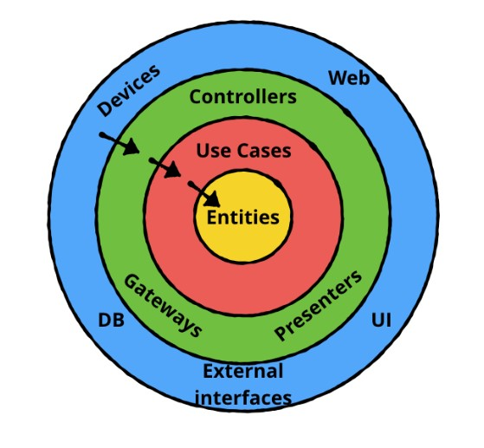](https://hsmnzaydn.medium.com/androidte-clean-architecture-kullan%C4%B1m%C4%B1-ca648d71b017)

Presenters:

* Layer that interacts with the user.

Data:

* It is the layer where abstract data is defined. We can give examples of response models.

This layer contains:

* + API: e.g.,

[metin içeren bir resim

Açıklama otomatik olarak oluşturuldu](https://hsmnzaydn.medium.com/androidte-clean-architecture-kullan%C4%B1m%C4%B1-ca648d71b017)

* + repository: It is used to make requests. E.g.,

[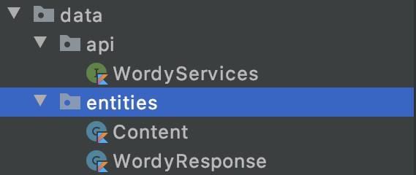](https://hsmnzaydn.medium.com/androidte-clean-architecture-kullan%C4%B1m%C4%B1-ca648d71b017)

* + entities: It is the folder where the responses from the backend are located. E.g.,

[metin içeren bir resim

Açıklama otomatik olarak oluşturuldu](https://hsmnzaydn.medium.com/androidte-clean-architecture-kullan%C4%B1m%C4%B1-ca648d71b017)

Use Cases:

* It is the layer where the things that users will do are defined. E.g.,

[metin içeren bir resim

Açıklama otomatik olarak oluşturuldu](https://hsmnzaydn.medium.com/androidte-clean-architecture-kullan%C4%B1m%C4%B1-ca648d71b017)

Framework:

* It is the layer that interacts with the SDK we are using.

Domain:

* It is the layer where logic operations are performed.

### Proposed Software Architecture

[metin içeren bir resim

Açıklama otomatik olarak oluşturuldu](https://nix-united.com/blog/the-comprehensive-guide-to-mobile-application-architecture/)

#### Security Architecture

Application security issues should not be largely ignored and focused on faster delivery of application features. Considering the feedback from authorized sources and customers, precautions should be taken against hackers or data leaks.

#### Dynamic Model

Sequence diagrams have been used to show the interaction between users, screens, objects and entities. Using this diagram, the login and registration scenarios of the users and how they will interact with the system are shown. Objects are represented by special drawings.

[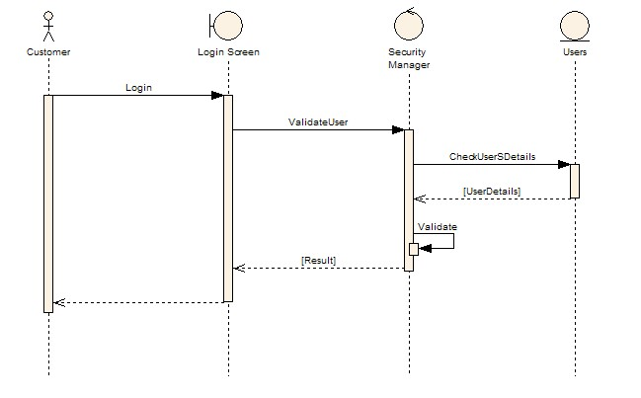](https://sparxsystems.com/resources/tutorials/uml/dynamic-model.html#:~:text=The%20dynamic%20model%20is%20used,extensions%20including%20business%20process%20modelling.)

### Subsystem Services

The subsystem is the place where the transactions to be made are processed in the system, and it is the place where the resource usage etc. It is the operating environment in which things are coordinated.

UI Interface Subsystem: Provides UI Interfaces to the various users of the system using mobile interface.

Admin Operations Subsystem: Admin to manually modify various database operations provides access. These may be required in the event of a system crash and recovery.

e.g.,

* modifyUser()
* listUsers()

User Management Subsystem: Provides some services to add and delete operations.

e.g.,

* CreateUser()
* DeleteUser()

### User Interface

Designing a UI is one of the most important parts of a project. A good and splendid UI allows users to do whatever they want with satisfaction and productivity. For this, it is important to make a user-centered design. UI requirements should be clarified at an early stage. In this case, group members come up with different ideas. Once the most suitable one has been chosen, it is to stick to the master plan as much as possible.

metin içeren bir resim

Açıklama otomatik olarak oluşturulduOur UI design did not deviate from what we planned at the beginning of the project. If we examine the design, first of all, when the application is opened, a Login screen greets the user. The application logo is at the top of this screen. (The application logo is not the same as the one designed at the beginning of the project. Later improvements were made.) In the middle of the page, there is a space for users to write mail and password. If the email format is incorrect (e.g., no '@') it will show an error message to the user. With "Forgot Password", if the user forgets his password, he can write his e-mail address and request a new password to his own e-mail address.

When the "Continue" button is pressed, the user can switch to the "home page" page if he has logged in before. The "megaphone icon" allows the user to hear (optional) bird sounds while logging in. If a user has not registered before, they are directed to the "Register" page with "Sign Up".

metin içeren bir resim

Açıklama otomatik olarak oluşturuldu

This page gives users the right to register on our application. To become a user, he has to fill in the Email, Name, Password, and Confirm Password fields. If information such as "Login" is not entered, the user will receive an error message.

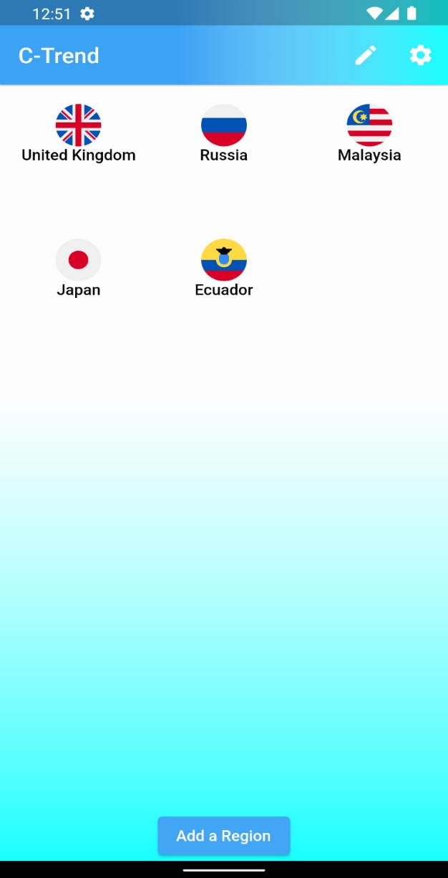

After the user logs in, the “Home Page” opens. This page is blank for the first-time user. There are flags and names of the countries they have chosen for subsequent users. Flags are also buttons. Since the user will add on this page, the page is designed simply.

There is an appbar at the top. There are two buttons on the appbar. With the one on the left, users can remove the countries they have selected. The other button takes the user to the settings page. With the "Add a Region" button, the "Select Region" page opens, where the user can choose what they want to add.

metin, ekran görüntüsü, elektronik eşyalar içeren bir resim

Açıklama otomatik olarak oluşturuldu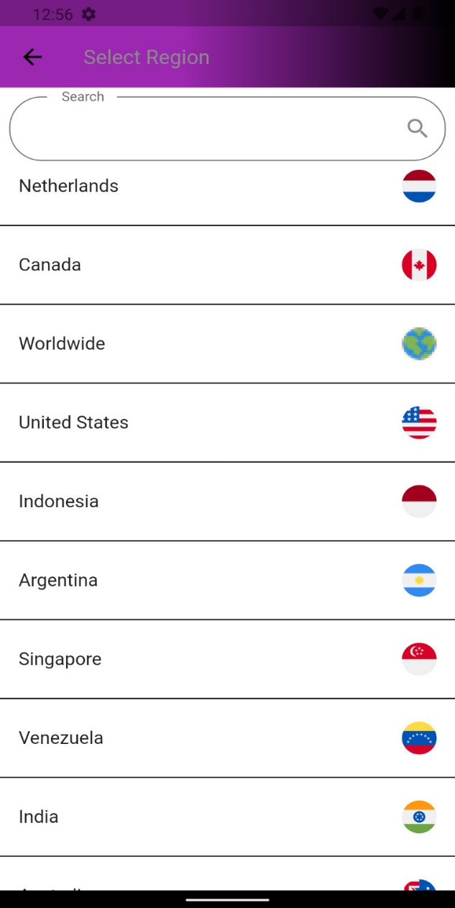

With “Select Region” page, the user can select the countries they want to see their trend or tweets. A search section has also been added to facilitate searching.

The other is the "settings" page. This page consists of three parts. With the "Account" section, a user can change their password or log out of the application. In the "Notifications" section, the user can select the country or city where the trends will be sent as notification by specifying the time interval. At the bottom, there is the dark mode mode. (Shown in the Settings page image.)

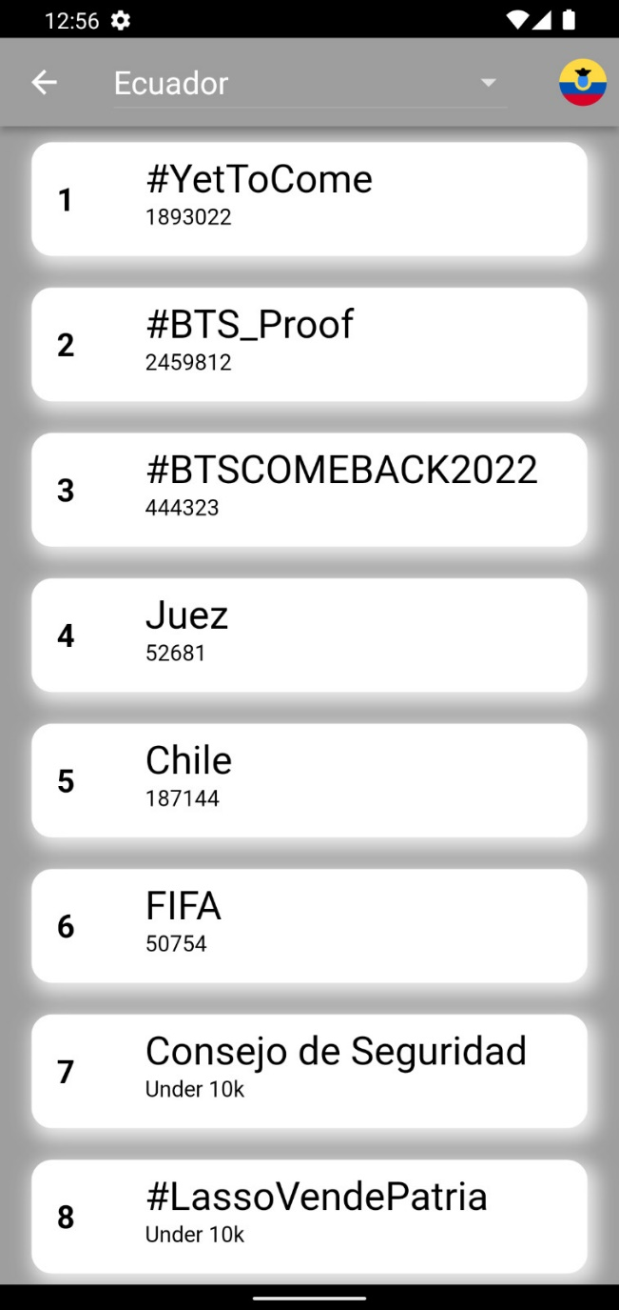The page that opens after the user presses the country button on the home page is as follows. Current trends are displayed on this page. In the appbar at the top, you can choose the general trend of the country or the trend of the cities.

metin içeren bir resim

Açıklama otomatik olarak oluşturuldu

By tapping on the trends, a page opens with the recent tweets of the trends. On this page, people's profile photos, locations, tweets, etc. information is displayed. If the user wants, he can select the number of tweets he wants to see by pressing the button in the upper right corner.

## Object Design

During the Object design phase, the connection between the user interface and the classes is designed and tried to be improved.

[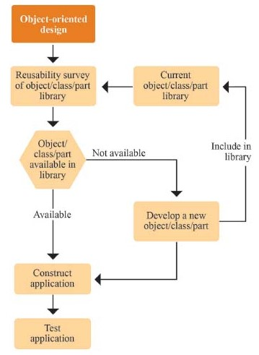](https://science.jrank.org/programming/ObjectOriented_Design_OOD.html)

## Test Plans

We can use following approach to analyze application.

[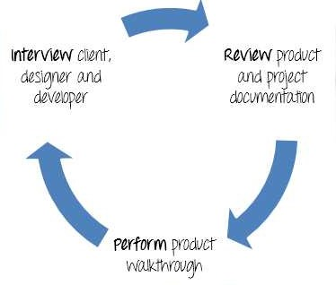](https://www.guru99.com/what-everybody-ought-to-know-about-test-planing.html)

Before starting test process, scope of the testing should be known. So, the components of the system to be tested are called as “in scope”.

Commonly used testing types are unit test, API testing, integration test, system test, install/uninstall test, and agile testing.

[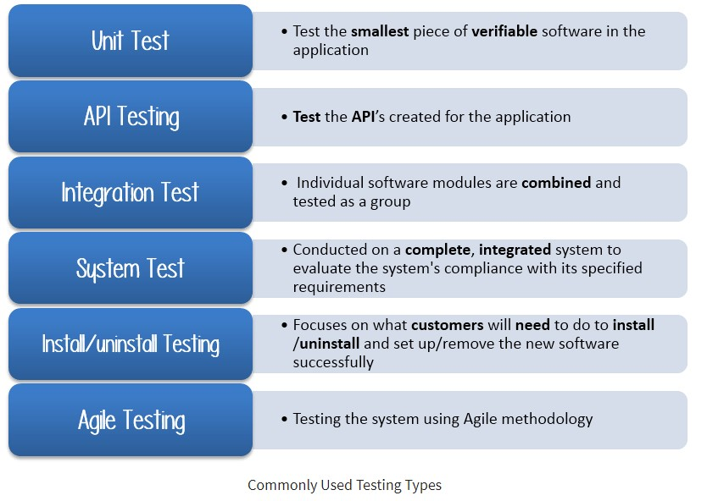](https://www.guru99.com/what-everybody-ought-to-know-about-test-planing.html)

API Testing: We used WOEID because sufficient information could not be obtained from Twitter using the keys given to us. No API issues have been encountered so far.

Integration Test: The works of the group members were combined via GitHub.

Install/Uninstall Testing: App play store etc. It has been tested by a small number of customers because it is not on platforms. For testing, customers downloaded the app APK file. No problems were encountered in the controls.

Agile Testing: Our project has been successfully completed since the beginning, thanks to the agile method.

System Test: The mobile emulators available with our personal computers provided the necessary environment for the project.

# Project Issues

## Product Use Cases

Use Case Diagrams

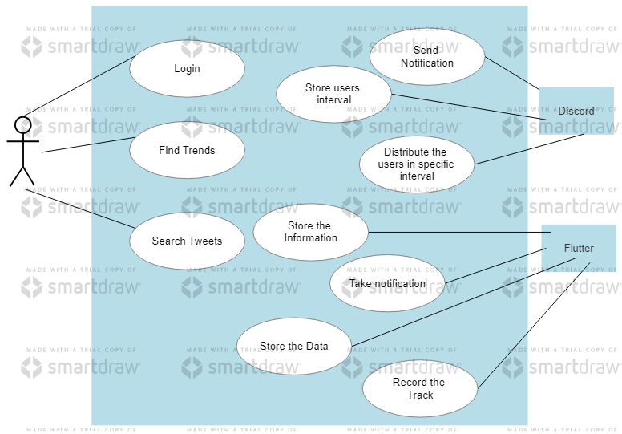

## Performance Requirements

## 23a Speed and Latency Requirements

Content

Describe the amount of the time for completing specified tasks. Requirements often refer to response times. Also, they can refer to ability of product to operate at a velocity suitable for intended environment.

Motivation

Some functions such as getting real time tweets should be able to perform in a specific time. Any fail in these functions may cause a problem in an application that may crash the program itself.

Examples

Any trends in the countryside should be seen to a user in a very short time like 1 seconds. If it will be so long, there will be problem.

The corresponding recent tweets into any trend should be the relevant one.

The application shall be fast enough and appropriate one to show that time trends and avoid from any problem.

The application should select correct country in an array to avoid from any complexity.

## 23b Precision or Accuracy Requirements

Content

Quantification the desired accuracy of the tweet results fetched by the application

Motivation

To determine the expectations of the users for the application and the tweets.

Examples

All tweets shall be appropriate with that specific trend.

All recent tweets shall be within that minute inside.

## 23c Capacity Requirements

This part will specify the volumes that the application should be able to deal with and the capacity of stored data by the application itself.

To avoid that the application is capable of processing the expected volumes.

Example

The application will allow a user to select one of the following country/city areas for taking a notification at a regular interval notification. So, no one can select all countries that would return their trends to

## Dependability Requirements

## 24a Availability Requirements

Content

This section tests the required usability of the product. Availability is often expressed as the ratio of the total time the system is up and ready to use.

Availability is called a function of the main time among the errors/failures, the main time to bring the application’s system back up after any wrong issue.

Motivation

There are some differences between how often an application goes down and how much total time that spends being shot down.

Example

The application shall be usable for use 365 day per year, 24 hours per day.

The application shall be available for use in a whole day.

## 24b Robustness of Fault-Tolerance Requirements

Content

Robustness describes that the ability of the application to continue to function itself under abnormal circumstances.

Motivation

To avoid some wrong issue or faults, the application should be able to provide some or all of their services during or after the issues that would crash the application even it is working.

## Maintainability and Supportability Requirements

## 25a Supportability Requirements Content

It describes the level of the support that the application requires.

There may be support to this application because Twitter is very popular nowadays. People spend their time on usually Twitter. Since this project will give you the notification in every hour, it depends on the user, the user will show what is going on in that specific area with the location too.

## 25b Adaptability Requirements

Describes environments or platforms to where/which product must be ported.

The application is based on mobile application in both iOS and Android side that Flutter/Dart allows firstly.

The product is expected to run under mobile platforms but there might be web site or desktop application that also they are giving notification without looking inside of the application itself.

The product may be also used in other platforms such as TVs. The news channel may use this one too.

The product will be beneficial for the analysts. They may use this one to search for the trend topics usage in a specific area.

## 25c Scalability or Extensibility Requirements

It specifies the expected rises in total size where the application should be able to take it.

The application, which is also made on the discord, will be available up to 250,000 people as discord allows. But in that time, it is up to discord side that is not affected by our application. Since Discord is used by free, there would be some problem. So, if application itself will gain some investment, the code would be transferred to an online and secure server that is working forever.

## 25d Longevity Requirements

This specifies the expected lifetime of the application.

The application shall be expected to be live at least a few years until the Twitter changes the Twitter API or Flutter allows never that Twitter package.

The product would be used forever if there will be no majority changes in the base of the codes.

## Security Requirements

## 26a Access Requirements

Every user can see the countries that twitter allows.

Only producers (team) of the application may manage the discord bot.

Manager of the application can see the devices token as well as the storage without specific information within the security Laws.

## 26b Integrity Requirements

The application does not allow user to give wrong information.

The application would change on the firebase and discord bots which depends on the online and the codes itself. It will survive even there will be small issues.

## 26c Privacy Requirements

The application is putting itself in safety. The passwords are in “hashed” mode so users ID and Passwords will be collected and stored secretly. Thus, privacy issues will be legal since there is some protecting and safety modes thanks to Google Firebase.

User will be informed by the application meanwhile in the future.

## Usability and Humanity Requirements

## 27a Ease of Use Requirements

The application interfaces are very basic for that reason, any user may use it basically.

The errors show where something is wrong in detail. So, user may find what is wrong basically.

## 27b Personalization and Internationalization Requirements

At the beginning of the project, the main language was English for even tweets. But since it goes up, you will find to chance to change the language.

## 27c Understandability and Politeness Requirements

The application shall hide the details of its construction from its users.

## Look and Feel Requirements

The product shall be attractive to everyone who interest in the news or world.

## Operational and Environmental Requirements

## 29a Expected Physical Environment

The product shall be used by everyone easily, who has a mobile phone.

The product shall not to be louder than the existing voice level in the environment.

## 29b Productization Requirements

The product will be distributed as ZIP files.

## Cultural and Political Requirements

The application will work on every language and every symbol that applications allows so every people from any culture can use it easily.

The cultural effect depends on the people who are sending some tweets.

## 30a Political Requirements

Since there is no usage in the application that user cannot send any tweets, there is no big deal with the political requirements since people do not go further.

## Legal Requirements

## 31a Compliance Requirements

User’s personal information will be implemented with some algorithms and also with the Data Protection Act.